Prevention and Control of Infection

**Introduction**

* Infection and infectious diseases in humans are caused when harmful germs, known as pathogens enter the body and multiply
* These micro-organisms are so small they can only be seen by using a microscope

**Pathogens:** A pathogen is something that causes a disease.

**Pathogens**

Pathogenic organisms can be:

* Bacteria
* Viruses
* Fungi
* Parasites
* Protozoa

**Bacteria** that can multiply quickly at body temperature and reach harmful levels very fast. Examples of harmful bacteria include meticillin-resistant Staphylococcus aureus (commonly known as MRSA) and Clostridium difficile (known as C.Diff or C. Difficile). These two types of bacteria caused, or contributed to, 9000 deaths in hospitals or primary care in 2007.

**Viruses** that can survive on surfaces and in food but can only multiply in living cells. It takes very few virus organisms to cause illness. They can be spread from person-to-person and from environment-to-food. Examples of viruses include Norovirus (also known as ‘winter vomiting disease’) and Influenza (the flu virus).

**Fungi** are organisms which live on hosts that can be alive or dead. Examples of fungal infections include; athlete’s foot and ringworm.

**Parasites** live on or in another plant or animal, known as the host. Scabies is caused by mites that burrow into the skin causing severe itching.

**Protozoa** are single-celled organisms that live in water and damp conditions. Malaria is an example of a disease caused by protozoa.

**Hosts** could describe the organism from which the parasite feeds or in which it lives or grows.

**Vulnerable people**

**People with weakened immune systems including:**

* Elderly people
* New born babies
* People with some long-term health conditions

**People who have broken skin (portal of entry) including:**

* An open wound
* A catheter or intravenous drip
* Burns or cuts to the skin
* Skin conditions such as ulcers
* People who have poor nutrition or poor general health

-Some groups of people may be more vulnerable to infection, for example because of age or ill or general health

-If these groups become infected the symptoms may be serious and life-threatening

-Micro-organisms that are resistant to antibiotics can make it difficult to treat the illness

**Chain of infection**

In order for the spread of infectious diseases to take place, the ‘chain of infection’ must be completed.

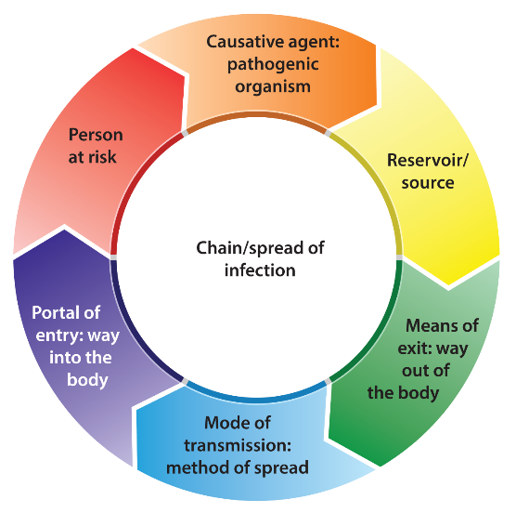

**Causative agent:** This is the harmful germ or pathogen that can cause infection, illness and disease. Examples include bacteria and viruses.

**Reservoir or source:** This is where pathogens live and multiply.

Remember, that could be in or on a person or animal (host), or in soil or water.

**Means of exit:** This is how pathogens leave the source. For example, pathogens that live in the respiratory tract (the lungs, throat, etc.) can leave the body through the mouth or nose in saliva or mucus when coughing or sneezing. Other examples of means of exit are broken skin, mucous membranes such as the eyes, via the stomach and via the intestines and anus.

**Mode of transmission:** It refers to how the pathogen is passed on from one person to another. Contact transmission is the most common route of transmission of pathogens in a health and social care workplace. This can happen by direct (hands) or indirect contact (equipment). Pathogens such as those that cause influenza and chicken pox can stay in the air for a long time and can be breathed in by other people.

**Portal of entry:** This is the way that the pathogen enters the body of the potential host. Pathogens can enter the body by coming into contact with broken skin, being breathed in or eaten, coming into contact with the eyes, nose and mouth or, for example when needles or catheters are inserted.

**Person at risk:** A person at risk is the individual the pathogen moves to. The risk of a person becoming infected depends on factors such as their general health and the strength of their immune system (which is the body’s system for fighting germs and micro-organisms).

**Breaking the chain**

* Preventing infection means breaking the links in the chain so that an infection cannot spread
* Not everybody who carries harmful micro-organisms will show symptoms

Examples of standard precautions taken in EVERY situation to reduce the risk of infection:

* Good hand hygiene
* Safe disposal of waste
* Safe management of laundry
* Correct use of Personal Protective Equipment (PPE).

**Your health and hygiene**

You have an important role to play in preventing the spread of infections

* Vaccinations
* Illness
* Clothing
* Personal hygiene
* Skin health
* Good hand habits

**Vaccinations:** It is your responsibility to keep up to date with your own vaccinations in line with the vaccination schedule as it is part of your duty to protect the individual.

**Illness:** If you have cold or flu symptoms, an upset stomach or skin infections, you should speak to your manager before reporting for work.

If you have diarrhoea or vomiting you should not attend work until you have been free from symptoms for 48 hours.

**Clothing:** Your clothes can become contaminated with harmful micro-organisms. Disposable aprons and over-sleeves should be used when handling anything contaminated with body fluids to protect clothes from contamination. Changing your clothing daily reduces the risk of remaining contaminants being spread to the individuals you provide support for. Uniforms or work clothing should be washed on a hot wash, then tumble-dried or hot ironed, to kill any bacteria present.

**Personal hygiene:** Personal hygiene is extremely important for people who take care of others. Daily washing, showering or bathing will remove most of the micro-organisms on your skin. Hand hygiene is also extremely important. Fingernails should be kept short. Rings (apart from plain wedding bands), wristwatches or bracelets should not be worn as they can make hand washing less effective.

**Skin health:** Micro-organisms can live on the skin. The number of pathogens increases when skin is damaged. All cuts should be covered with a waterproof dressing. Using hand cream, good quality paper towels and soaps can help to protect the skin.

**Good hand habits:** Having good hand habits means not touching areas that can be a source of pathogens more than you need to. These areas include your nose, hair and mouth, and not biting nails. This also applies to work practices such as using foot operated bins rather than lifting bin lids with your hands.

**Hand hygiene**

Hand hygiene is an important part of preventing infection Hands can be cleaned, or decontaminated by:

* Washing with water and soap that removes dirt and germs from the hands but doesn’t kill them
* Using alcohol hand rubs and gels which kill most bacteria

**5 moments for hand hygiene**

The World Health Organisation has identified ‘5 moments’ when health and social care workers should clean their hands. These moments are:

1) Before touching the individual you are supporting

2) Immediately before carrying out a ‘clean’ procedure

3) After exposure to body fluids and after removing gloves

4) After touching the individual you are supporting

5) After touching the area or objects surrounding the individual you are supporting

**Effective hand washing**

For hand washing to be effective every part of your hands are carefully washed, rinsed and dried. The steps below show you how to ensure that your hands are washed correctly:

1) Wet hands and wrists thoroughly using warm running water

2) Apply liquid or foam soap

3) Produce a good lather; rub palms together, interlock fingers, rub together again

4) Rub palms ensuring fingertips and fingernails are cleaned

Ensure that the backs of your hands are lathered and cleaned

5) Rub with fingers locked, maintaining a good lather to ensure that wrists are cleaned

6) Rinse hands thoroughly using running water

**Personal Protective Equipment (PPE)**

* Enough uniforms for regular changing and washing
* Disposable aprons to protect clothing and uniforms from contamination from blood and body fluids etc.
* Skin protecting paper towels and soaps
* Hand cleansing gels or wipes
* The correct type of gloves to reduce the risk of cross-contamination of you and the individual you are supporting
* Masks and respiratory-masks to protect you from breathing in harmful micro-organisms
* Goggles, eye protection and face shields – if there is a risk of being splashed with body fluids

Your employer must provide you with the equipment you need to protect you from harm

**Soiled linen**

Linen can become contaminated with harmful micro-organisms and body fluids

**Precautions for dealing with contaminated linen include:**

* Wearing PPE
* Washing contaminated linen separately
* Washing clothing in 40°C-50°C wash followed by tumble-drying or hot ironing
* Washing bedding and towels in a hot wash
* Sealing laundry in colour coded bags and moving to the washing area
* Washing infected linen immediately if you are supporting people in their own home